**ASSIGNMENT 2**

Ritik Shah (220894) , Shreya Gupta(221027)

## I) **DESIGNING THE STRATEGY:**

### **LEARNING ABOUT THE INDICATORS:**

-> **DONCHIAN CHANNELS :**

The Donchian Channel is a technical analysis indicator developed by Richard Donchian, used to identify potential breakouts and trend reversals in financial markets. It consists of three lines: the upper channel line (UCL), the lower channel line (LCL), and the middle line (MCL).

The formulas to calculate the Donchian Channel lines are as follows:

1. Upper Channel Line (UCL): This line represents the highest price observed over a specified period (N).

2. Lower Channel Line (LCL): This line represents the lowest price observed over a specified period (N).

3. Middle Channel Line (MCL): This line is the average of the upper and lower channel lines.

MCL = (UCL + LCL) / 2

Traders commonly use a 20-day period (N = 20) for the Donchian Channel, but the period can be adjusted based on the trading strategy and market conditions.

— Breakout Above UCL: When the price breaks above the upper channel line, it suggests a bullish trend, and traders may consider buying opportunities or holding existing long positions.

— Breakout Below LCL: When the price breaks below the lower channel line, it suggests a bearish trend, and traders may consider selling or shorting opportunities.

-> **RELATIVE STRENGTH INDICATOR:**

The Relative Strength Index (RSI) is a popular technical analysis indicator used to measure the speed and change of price movements in financial markets. It provides insights into overbought and oversold conditions of an asset and helps identify potential trend reversals.

The RSI is calculated using the following formula:

RSI = 100 - (100 / (1 + RS))

To calculate the RSI, following steps need to be followed:

1. Calculate the average gain (upward price changes) and average loss (downward price changes) over the selected number of periods (x).

- Average Gain = Sum of gains over x periods / x

- Average Loss = Sum of losses over x periods / x

2. Calculate the Relative Strength (RS) using the following formula:

- RS = Average Gain / Average Loss

3. Finally, calculate the RSI using the formula:

- RSI = 100 - (100 / (1 + RS))

The RSI is typically displayed as a graph with values ranging from 0 to 100.

1. **CODING:**

The attached code includes the implementation of RSI and Donchian Channels along with comprehensive documentation to ensure clarity and eliminate any ambiguities.

**II) STRATEGY:**

1. **DONCHIAN CHANNELS:**

**OPTION_1) BREAKOUT INDICATORS:**

The Donchian Channel breakout strategy is a popular trading approach that utilizes the Donchian Channel indicator to identify potential breakout opportunities.

1. Identify Breakout Conditions:
   * Look for a bullish breakout: When the price closes above the UCL, it suggests a potential bullish trend and a breakout signal.
   * Look for a bearish breakout: When the price closes below the LCL, it suggests a potential bearish trend and a breakout signal.

2. Enter the Trade:

* For a bullish breakout, consider entering a long position (buy).
* For a bearish breakout, consider entering a short position (sell or short-sell).

**OPTION_2) TRADING WITH THE MIDDLE:**

The Donchian Channel middle line strategy is a trading approach that focuses on the middle line (MCL) of the Donchian Channel.

1. Determine the Trend Bias:
   * Assess the position of the price relative to the MCL.
   * If the price is above the MCL, it suggests a bullish bias.
   * If the price is below the MCL, it suggests a bearish bias.
2. Entry Conditions:
   * For a bullish bias, consider entering a long position when the price pulls back and touches or slightly dips below the MCL.
   * For a bearish bias, consider entering a short position when the price rallies and touches or slightly moves above the MCL.

After experimenting the two strategies we found that trading with the middle seemed to be more fruitful, especially in the case of large cap stocks, where chances of breakout are small.

**B) RELATIVE STRENGTH INDICATOR:**

1. Identify Overbought and Oversold Levels:
   * Determine the threshold levels for overbought and oversold conditions. Commonly used levels are 70 for overbought and 30 for oversold.
   * Values above 70 indicate overbought conditions, suggesting a potential price reversal or correction.
   * Values below 30 indicate oversold conditions, suggesting a potential price bounce or trend reversal.
2. Entry Conditions:
   * For oversold conditions (RSI below 30), consider entering a long position (buy) as a potential reversal or bounce may occur.
   * For overbought conditions (RSI above 70), consider entering a short position (sell or short-sell) as a potential reversal or correction may occur.

**III) PERFORMANCE ANALYSIS:**

Stock name : Angel one

* **Output using Donchian channels (volatility indicator):**

**DC condition:**





**Backtesting condition:**





**Result:**

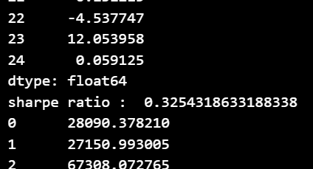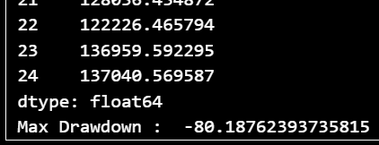

* **Output using RSI ( Momentum Indicator):**

**Backtesting Condition:**





**Result:**

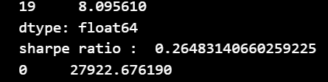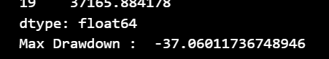

* **Output using both the indicators together:**

**DC condition:**



**RSI condition while backtesting:**

**Result:**

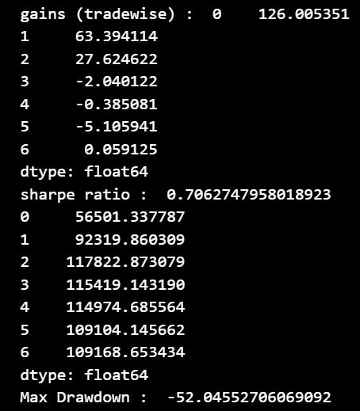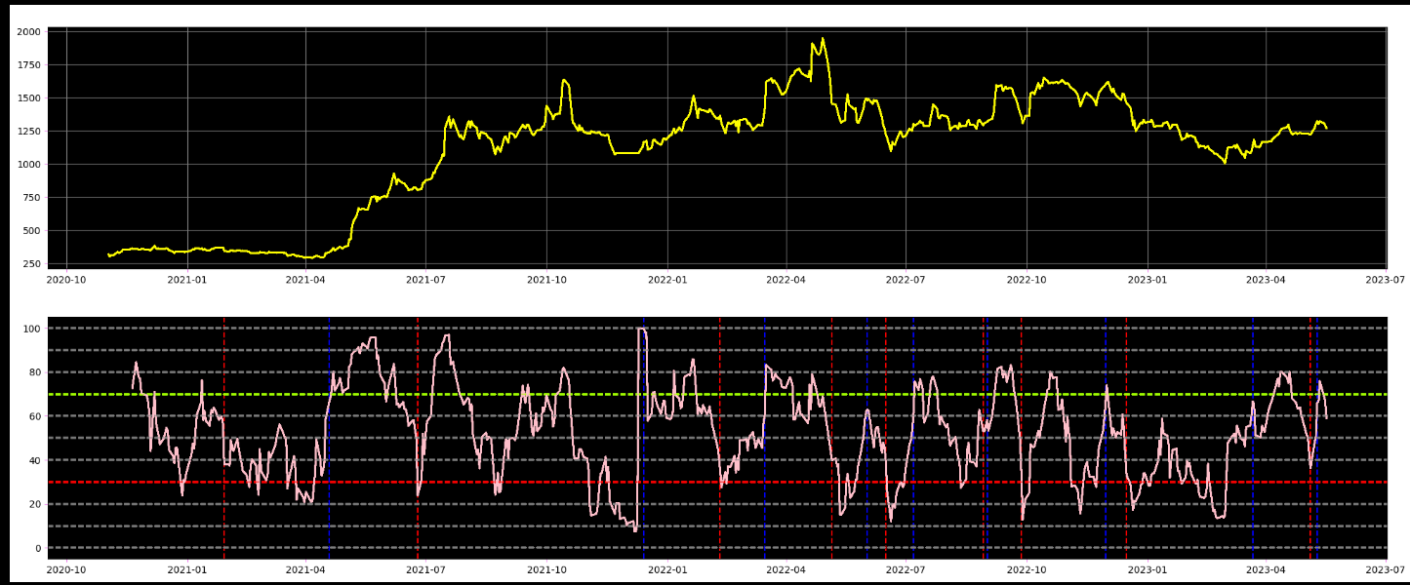

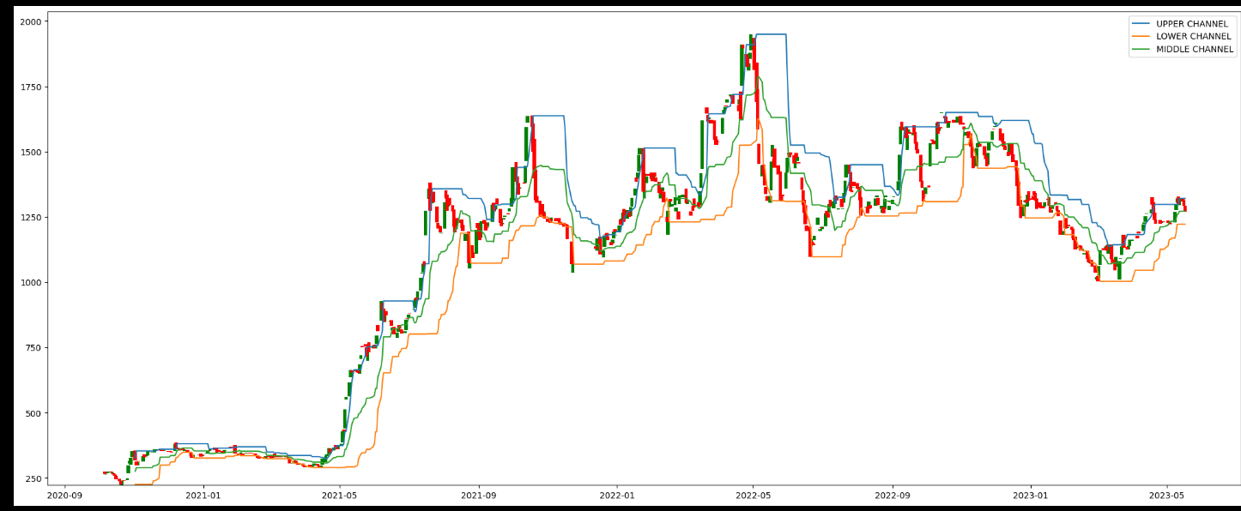

1. **Changing the RSI conditions:**

**Fixed DC condition :**

1. **Changing the RSI range:**

**Trial#1**

**RSI Condition:**





**Result:**

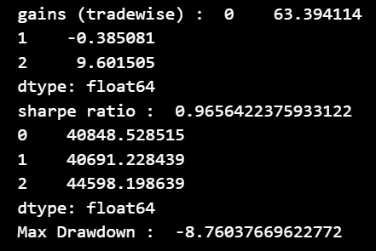

**Trial#2**

**RSI Condition**:





**Result:**

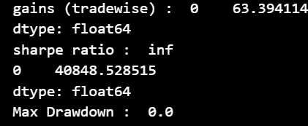

**Trail#3**

**RSI condition:**





**Result:**

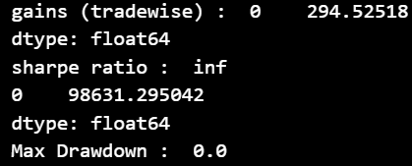

Here we see that changing the RSI range to (40,60) gives a desirable sharpe ratio.

1. **Changing the no. of days before the day of interest**

**Trial#1**

**RSI condition:**





**Result:**

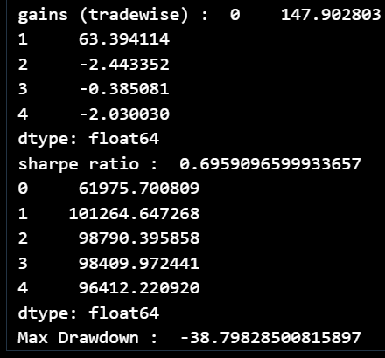

**Trial#2**

**RSI Condition:**





**Result:**

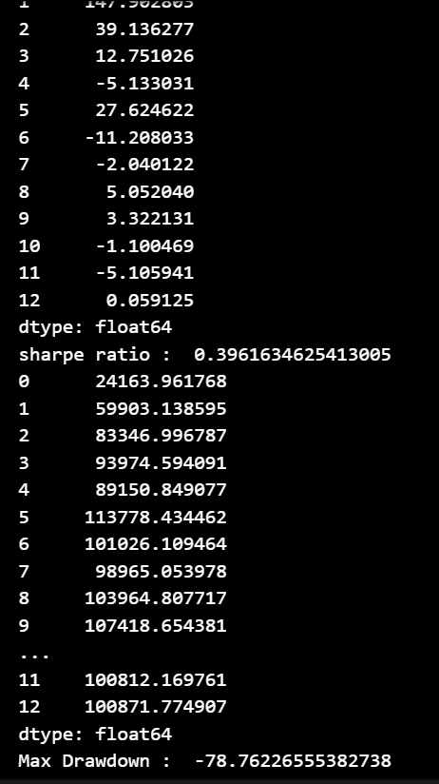

Here we see that the conditions on RSI have been relaxed to allow RSI to be in overbought or oversold levels for up to 5 days before day of interest, but this results in worsening of sharpe ratio.

**IV) Improvements:**

Our objective is to create an ML model capable of analyzing a diverse range of stocks and dynamically adjusting our trading strategy. By incorporating factors such as oversold and overbought thresholds, the model will optimize our trading decisions, ultimately maximizing returns across multiple stocks. Furthermore, a well-executed implementation of shorting will further enhance our yield potential. This comprehensive approach ensures the practical viability of our strategy in real-world trading scenarios.

**V) Contributions in detail :**

-> Coding and plotting of DC: Ritik

-> Coding and plotting of RSI : Shreya

-> Combining indicators: Ritik and Shreya

-> Plotting in combined indicator strategy : Shreya

-> Testing different strategies related to DC : Ritik

-> Testing different strategies related to RSI : Shreya

-> Working on Sharpe Ratio:Shreya

-> Working on MDD : Ritik

-> Document outlining: Ritik

-> Document detailing : Shreya